The Power of Presence is a workshop adhered to quieting the mind to experience the present moment because that is where we will find all are answers, they are not outside but within. The herd are the master teachers in being in the now, they know instinctively how to do this.
Today’s modern world is filled with chaos, noise, obligations, differing opinions, and circumstances beyond your control.
How does one not get swept away and lost? How does one remain centered and clear?
Through the power of Presence.

You will experience a Native American Smudge ceremony to begin the weekend, followed by meeting the horses and reflective grooming.

Each participant will then have a session with a chosen horse from the herd.

You will also have the opportunity to walk a labyrinth with or without a horse.
You’ll be loving held in the space and expertly guided through the blocks, obstacles, beliefs and emotions that keep you from being present.

Come along on an exciting journey to re-discover your inner teacher again through the power of presence. Open your heart through the Smudge, horses, guides Sarah and Diana and experience how:

- Presence creates a life of awareness, rather than a life of tentative action or speculation.
- Clarity replaces distractions
- Your inner guidance replaces chaos and noise.
- Return home with renewed passion.

Saturday October 7, 2017
9:00am – 5pm
Desert Awakenings Ranch
36646 N 21 St
Phoenix AZ 85086

Registration $175 ** Early Registration $149. When completed by Sept. 1**
Credit cards accepted.
Lunch required and feast @ 4pm is offered to those who would like to participate in a social time and spiritual celebration of their weekend experience.

Sarah Charuk -
Desert Awakenings and Diana Gogan - Fire Horse Ranch
join to bring you
The Power of Presence

Confident . Clear. Centered
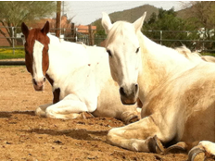

October 7, 2017
Desert Awakenings Ranch
Phoenix, Arizona

The Sacred Smudge Ceremony

The smudge ceremony is a Native American practice for spiritual cleansing, bringing in positive energy.

Led by
Sarah Charuk and Diana Gogan

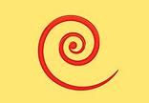

Diana Gogan
Fire Horse Medicine Woman from Fire Horse Ranch

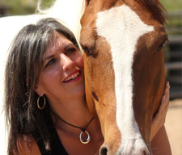

“As presence arises you’ll find in many areas of your life enormous improvements” – Eckhart Tolle

Sarah Charuk
Native American Awakening Guide from Desert
Awakenings

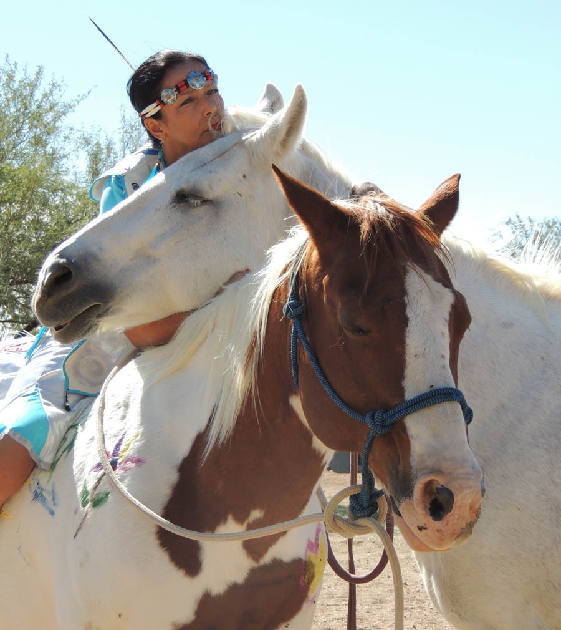

Our beautiful horses are waiting to meet you. Each has their own unique
personality and way of being to help you discover the power of presence.
Their presence is welcoming and satisfying as they help open new doors of discovery for your own answers, bringing fresh awareness of your heart’s truest desires.
We welcome you to join us for a truly exceptional experience!
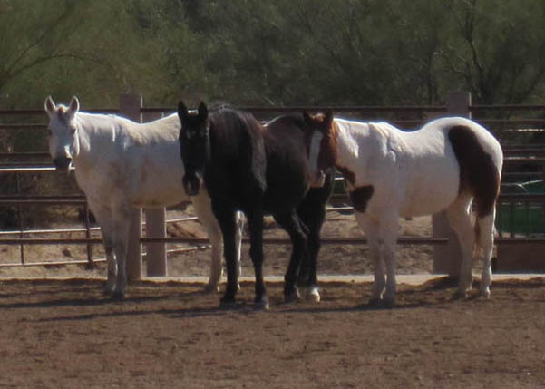

Graycie – a Quarter Horse
Stormy – a Tennessee Walking Horse
Tewa – a Paint Horse
All work with horses is on the ground with no riding.

Contact and sign up information

Sarah Charuk
sarah@desertawakenings.com
480-489-1925

Diana Gogan
diana@firehorseranch.com
480-720-0676

